Shared Memory Systems
# Source: AI Source: Provided by: [Data Path: Persons Table -> ID Column: 1, Name_En Column: Motasem Essam] -> From: [ChatGPT] on [1/16/2026]
A Shared Memory System is a type of distributed system in which multiple processes (or nodes) share a common memory space to communicate and coordinate, instead of sending messages.
This approach is used when processes are closely coupled and can access the same memory location to read or write data.

Definition
# Source: AI Source: Provided by: [Data Path: Persons Table -> ID Column: 1, Name_En Column: Motasem Essam] -> From: [ChatGPT] on [1/16/2026]
A Shared Memory System:
- Provides a common memory area accessible by multiple processes
- Processes communicate by reading and writing shared variables
- Synchronization mechanisms like locks, semaphores, or monitors are needed to avoid conflicts

Architecture Diagram
# Source: AI Source: Provided by: [Data Path: Persons Table -> ID Column: 1, Name_En Column: Motasem Essam] -> From: [ChatGPT] on [1/16/2026]
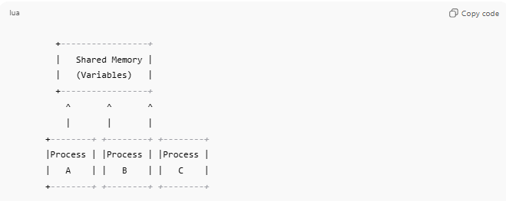
+-----------------+
| Shared Memory |
| (Variables) |
+-----------------+
^ ^ ^
| | |
+--------+ +--------+ +--------+
|Process | |Process | |Process |
| A | | B | | C |
+--------+ +--------+ +--------+
- All processes can access the same shared memory
- Processes must coordinate to avoid data inconsistency

Key Characteristics
# Source: AI Source: Provided by: [Data Path: Persons Table -> ID Column: 1, Name_En Column: Motasem Essam] -> From: [ChatGPT] on [1/16/2026]
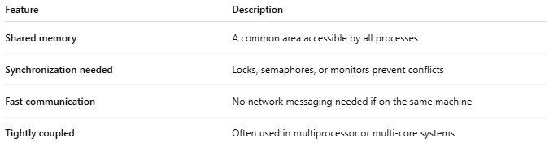
Feature | Description
Shared memory | A common area accessible by all processes
Synchronization needed | Locks, semaphores, or monitors prevent conflicts
Fast communication | No network messaging needed if on the same machine
Tightly coupled | Often used in multiprocessor or multi-core systems

How It Works
# Source: AI Source: Provided by: [Data Path: Persons Table -> ID Column: 1, Name_En Column: Motasem Essam] -> From: [ChatGPT] on [1/16/2026]
- Processes access shared variables in memory
- They read or write data as needed
- Synchronization mechanisms ensure mutual exclusion
- Data is immediately available to all processes

Advantages
# Source: AI Source: Provided by: [Data Path: Persons Table -> ID Column: 1, Name_En Column: Motasem Essam] -> From: [ChatGPT] on [1/16/2026]
- Fast communication compared to message passing
- Simple data sharing for tightly coupled systems
- Efficient for multiprocessor systems

Disadvantages
# Source: AI Source: Provided by: [Data Path: Persons Table -> ID Column: 1, Name_En Column: Motasem Essam] -> From: [ChatGPT] on [1/16/2026]
- Difficult to implement over distributed networks
- Requires synchronization mechanisms to avoid conflicts
- Limited scalability beyond a single location
- Can be prone to deadlocks or race conditions

Examples
# Source: AI Source: Provided by: [Data Path: Persons Table -> ID Column: 1, Name_En Column: Motasem Essam] -> From: [ChatGPT] on [1/16/2026]
- Multi-threaded applications sharing memory
- Multi-core processors in a single server
- Shared database buffers
- POSIX shared memory in UNIX/Linux systems

Simple Analogy
# Source: AI Source: Provided by: [Data Path: Persons Table -> ID Column: 1, Name_En Column: Motasem Essam] -> From: [ChatGPT] on [1/16/2026]
- Shared Memory System: Multiple people working on one whiteboard
  - Everyone can write or read on it
  - They must take turns or coordinate to avoid overwriting each other’s work

